ACH TRANSACTIONS AUTHORIZATION AGREEMENT

☐ NEW ☐ REVISE ☐ TERMINATE (Check One)

I (we) authorize [INSERT YOUR COMPANY NAME HERE] to electronically debit my (our) account (and, if necessary, electronically credit my (our) account to correct erroneous debits) to my ☐ CHECKING ☐ SAVINGS account (Check One) at the financial institution (Bank) named below.

Bank Name ______________________________________________________________________________
Bank Address ____________________________________________________________________________
Routing Number ____________________________ Account Number _______________________________

ATTACH VOIDED CHECK HERE
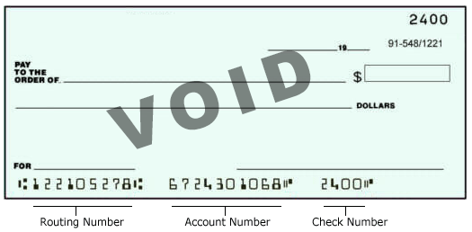

* * * Free PDF Preview End * * *
Purchase Required To Gain Total Access
Visit www.propmgmtforms.com To Purchase Property Management Forms Package

